**Your Paper Title Starts Here: Please Center and use**

**Times New Roman (Bold) 16 pt**

(11 pt blank line)

(11 pt blank line)

Author1*, Author2, Author3

(11 pt blank line)

< Times New Roman 10pt>1Faculty of Education, Universiti Teknologi MARA,

UiTM Puncak Alam Campus, 42300 Puncak Alam, Selangor, Malaysia

yuenfook@salam.uitm.edu.my

2School of Mathematical Sciences, Universiti Kebangsaan Malaysia,

43600 UKM Bangi, Selangor, Malaysia

tklee@yahoo.com

3Institute of Educational Leadership, Universiti Malaya, Kuala Lumpur, Malaysia

sathia@yahoo.com<Times New Roman 10pt>

*Corresponding Author

(10 pt blank line)

https://doi.org/ (leave blank)

(10 pt blank line)

*Received:* (leave blank)

*Accepted:* (leave blank)

*Date Published Online:* (leave blank)

*Published:* (leave blank)

(11 pt blank line)

(11 pt blank line)

**Abstract**: The abstract (approximately 150 to 250 words) should briefly describe the background, methods, results and conclusions of your research. It should be written in a single paragraph using single line spacing, Times New Roman, font size 11, justify and A4 format. Do not include reference citations in the abstract.

(10 pt blank line)

**Keywords**: Keyword1, Keyword2, Keyword3 (maximum of five subject keywords, in alphabetical order, each keyword should not contain more than two compound words)

1. **Introduction**

It is expected that authors will submit carefully written and proofread material. Selected conference papers (written in English only) will be reviewed for consideration to be listed as articles in scopus indexed Pertanika JSSH or MJLI journals or Springer book chapters which is indexed by Thompson Reuters/ISI, while other conference papers will be published in Asian Journal of University Education which is indexed in MyCite, DOAJ, UDL Edge, EuroPub and Google Scholar. Please use British English only. The maximum page length should be not more than 10 pages, including text, tables, figures and references.

State the background, a short literature survey and objective(s) in Introduction section. Use the international system of units (SI). Technical terms should be explained unless they may be considered to be known to the conference community. State the corresponding author. The manuscript should at least contain Introduction, Method, Results and Discussion, Conclusion, Acknowledgement and References.

1. **Paper Format**

Paper must be prepared on A4 size (210297 mm) with 1 inch margins left, right, top and bottom. The submission file is in Microsoft Word/Open Office document file format. Prepare text in a single column and use font type Times New Roman, size 11 pt. All text paragraphs should be single spaced, with first line indented by 10 mm. No spaces should be placed between paragraphs. Do not underline email addresses or URLs and do not typeset them in blue color. Do not include page numbers and running heads. All section titles must be First Letter Capitalized.



* 1. **Emphasis and Special Types**

Italics should be used for emphasizing words or phrase in running text, but do not format entire paragraphs in italics.

* 1. **Tables and Figures**

The tables and figures should be numbered consecutively. Figures and tables haven't cited in the text should not be presented. Figures and tables should be placed close after their first reference in the text. All figures, tables, formulas, etc. must be within the margin. The tables and figures should be one line of space above and one line of space below before the text continues.

* + 1. **Table Formats**

Use the table function to create and format tables. Do not use the space bar or multiple tabs to separate columns and do not use Excel to create tables as this can cause problems when converting your table into the typesetting program and others format.

* + 1. **Table Captions**

Table captions begin with the term Table in bold type, followed by the table number, also in bold type. Table captions should be centred above the table. The following is the example for Table 1.

**Table 1**. Title of the table

|  |  |  |  |  |
| --- | --- | --- | --- | --- |
| Rauracis |  |  | Latobrigis |  |
| Year |  | Tulingis | *M* | *1 SD* |
| 2 |  | 5 | 0.75 | 0.41 |
| 3 |  | 6 | 0.62 | 0.23 |
| 4 |  | 16 | 0.89 | 0.52 |
| 5 |  | 7 | 1.24 | 0.36 |

*m* mean, *1 SD* standard deviation

* + 1. **Figure Formats**

Graphic and diagrams should be saved as EPS (encapsulated postscript) files with the fonts embedded, Microsoft Office files (excel or PowerPoint) can be submitted in the original format (xls, xlsx, ppt, pptx). Scanned graphics in TIFF format should have minimum resolutions of 1200 dpi. Photos or drawings with fine shading should be saved as TIFF with a minimum resolution of 300 dpi.

A combination of halftone and line art (e.g. Photos, containing line drawing or extensive lettering, color diagrams, etc.) should be saved as TIFF with a minimum resolution of 600 dpi.

* + 1. **Figure Captions**

Figure captions begin with the term Fig. in bold type, followed by the figure number, also in bold type. Figure captions should be centred below the figures as shown in Fig. 1.The figures should be 78 mm – 117 (3-4 ½ inches) wide and not higher than 198 mm (7 ¾ inches). Color figures will appear in color in the eBook, but will usually be printed in black and white. Sample figure is shown in **Fig. 1.**

* 1. **Equations**

Equations should be numbered consecutively with equation numbers in parentheses on the right-hand edge of the text as shown in Eq. (1).

(1)



The equation should be one line of space above and one line of space below before the text continues. In Word, use the Math function of Word 2007 or 2010, Mathtype or Microsoft Editor to create your equations and make sure super- and subscripts are distinguishable. Within equations, number, punctuation, parentheses, common function names, units or mathematical signs are set upright. The variables are set in italics and vectors are set in bold. Digits are used for all numbers larger than ten. Commas are used to separate thousands and decimal point to separate decimals.

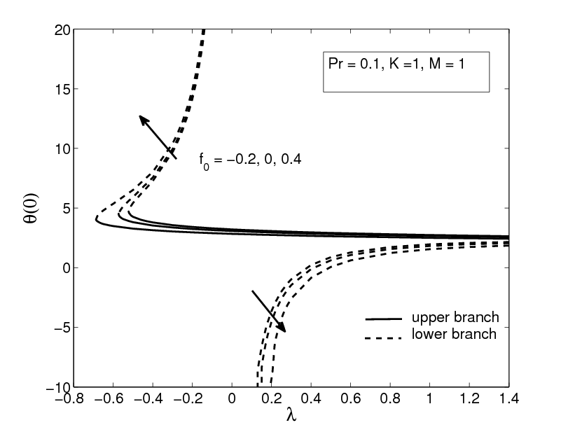

**Fig. 1** This is the first figure as EPS (encapsulated postscript) format (Yacob et al. 2011)

* 1. **Program Codes**

Program listing or program commands in the text are normally set in typewriter font, e.g: CMTT10 or courier new.

Global optimal solution found.

Objective value: 1.000000

Total solver iterations: 5

Variable Value Reduced Cost

U1 0.2000000 0.000000

V1 0.1000000E-03 0.000000

W1 0.5228615E-01 0.000000

W2 0.1323062 0.000000

W3 0.1000000E-03 0.000000

Row Slack or Surplus Dual Price

1 1.000000 -1.000000

HOSPITAL1 0.000000 -1.000000

HOSPITAL2 0.4129262 0.000000

HOSPITAL3 0.000000 0.000000

PENYEBUTHOSPITAL1 0.000000 -1.000000

6 0.000000 0.000000

7 0.1999000 0.000000

8 0.5218615E-01 0.000000

1. **Conclusion**

Do not submit a reworked version of a paper you have submitted or published elsewhere. All submissions are peer-reviewed by at least two reviewers. If you have problems submitting your paper online, please email your paper to ajue@uitm.edu.my (Contact person : Dr Norazah Abdul Aziz).

1. **Suggestion for Future Research**

Based on the most crucial factors that have been identified in this study, please suggest the new direction, new objectives, and new method for this similar study in the future. Adding this section adds value to the article by building upon the findings of this research and addressing the limitations and unanswered aspects of this study.

1. **Co-Author Contribution**

The authors affirmed that there is no conflict of interest in this article. Author1 carried out the fieldwork, prepared the literature review and overlook the writeup of the whole article. Author2 wrote the research methodology and did the data entry. Author3 carried out the statistical analysis and interpretation of the results.

1. **Acknowledgements**

Please state the research grant obtained to sponsor this work. List here individuals who provided help during the research. If no acknowledgement is necessary, this section should not appear in the paper.

1. **References**

Cite references in the text with author name/s and year of publication in parentheses (“APA Writing Style”).For one or two authors, the references should be cited as Egan (2008), (Egan, 2008), William and Lewis (2011)  or (William & Lewis, 2011). For three or more authors, include only the surname of the first author followed by et al. and year of publication, e.g. Cheng et al. (2012) or (Cheng et al., 2012). For two or more papers published in the same year by the same author(s), it can be written as Cheng et al. (2012a,b). If two or more authors are cited at the same point in the text, then they are included in the same in-text citation, separated by a semicolon, e.g. (Egan, 2008; William & Lewis, 2011). Authors are also required to cite preferably three (3) articles or a minimum of one (1) article that has been published in AJUE.

Please ensure that every reference cited in the text is also present in the reference list (and vice versa). Maximum number of references is 20. The references should be in alphabetical order. See examples in the list of references below.

Below are examples of entries for journal article, newspaper article, article in electronic journal by DOI (no paginated version), online document, jounal article with DOI  (and with page numbers), book chapter and book.

Chen, S. J., & Chen, S. M. (2007). Fuzzy risk analysis based on the ranking of generalized trapezoidal fuzzy numbers. *Applied Intelligence, 26*(1), 1-11.

Chua, D. (2014, April 25). New wave of choreographers. *New Straits Times*, p.7.

Gomez, M.M., Sierra, J.M.C., Jabaloyes, J.,  & Zarozo, Manuel. (2010).  A multivariate method for analyzing and improving the use of student evaluation of teaching questionnaires: A case study*. Quality Quantitative*. doi: 10.1007/s11135-010-9345-5.

Gunkel, M. (2008). Guidelines for academic writing. <http://www.im.ovgu.de/im_media/downloads/examinations/academic_paperwriting_MG.pdf>. Accessed 20 Feb 2014.

Kahraman, C., Cevi, S., Ates, N. Y., & Gulbay, M.  (2007).  Fuzzy multi-crieria evaluation of industrial robotic systems*. Computer & Industrial Engineering*, 52, 414-433 (2007).  doi: 10.1016/j.cie.2007.01.005.

Ramli, N., & Mohamad, D. (2010). On the Jaccard index with degree of optimism in ranking fuzzy numbers. In E. Hullermeier, R. Kruse, & F. Hoffman (Eds.), *Information processing and management of uncertainty in knowledge-based system application* (pp. 383-391). New York: Springer.

Rosen, K.H. (1988). *Discrete mathematics and its applications*. New York: Random House, Inc.